Pocket Astronomer Android Project Proposal

This app will inform users of upcoming astronomical events, such as eclipses, transits, comets, etc. It will also provide a summary of current astronomical conditions. These will be based on location.

Planned activities:

* Main: Summary of current astronomy stuff (like current lunar phase, countdown until sunrise/sunset)
* List of events in the near future (can be filtered to viewable at current location)
* App preferences (will include setting up push notifications)
* Persistent notification with tiny summary, push notification for Important Astronomical Events™.
* Import astronomical event into a calendar

Create rough sketches of the activities and indicate the flow between them.

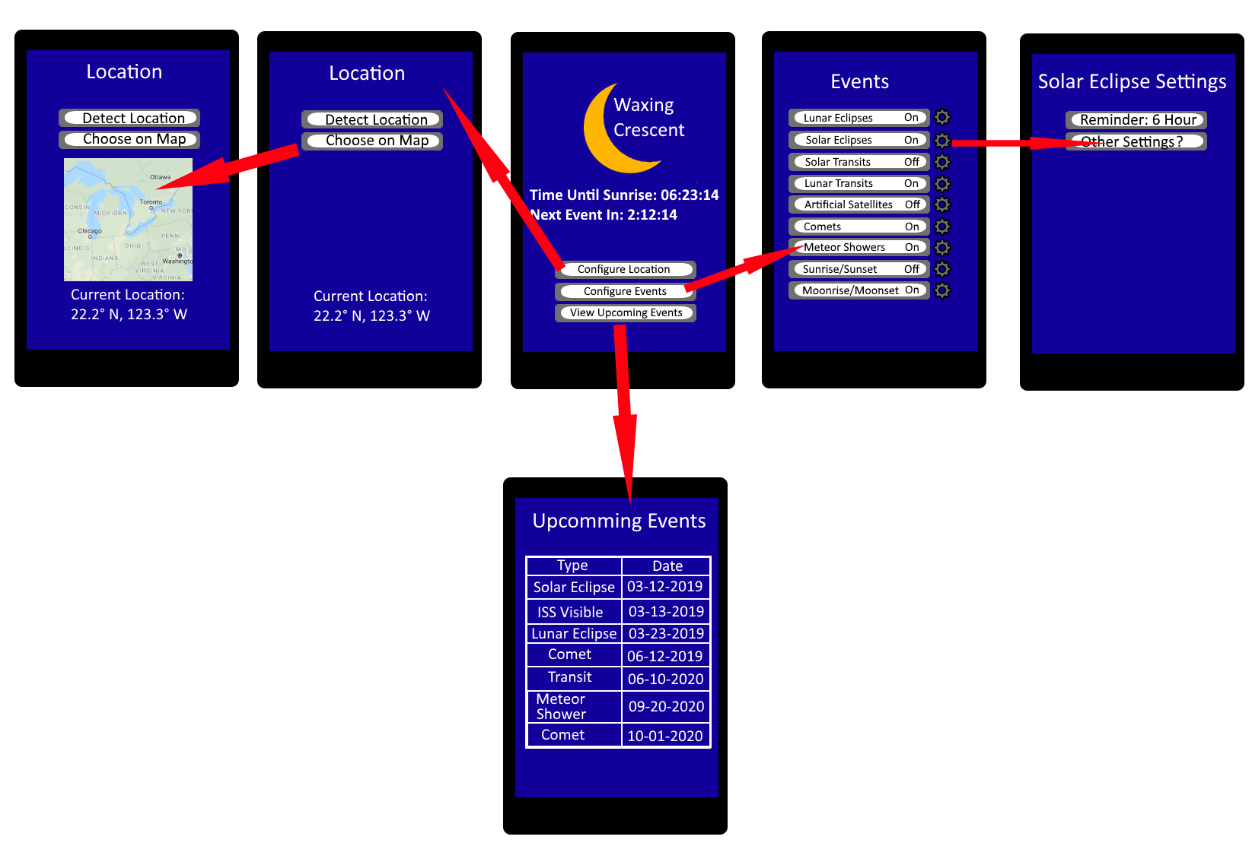

Persistent data stored within the app

* User settings
* Cached copy of the astronomical events (hold the current lunar phase for the current day and hold around week (or longer) of astronomical data, both pulled from web source)

Data from web sources

* Astronomical data will be aggregated from different sources through APIs and data scraping into a database. We will build a REST API to provide the mobile application with access to this data.